Thank you so much for all of the Grace Members who contributed to our second Lenten Reflection Guide.

This is truly a gift to our parish and a way to connect during this very special time of the year when we are called to pause from our daily lives and think about sacrifice and love and what our faith really means to us.

On our 275th Anniversary year it is especially meaningful to think of the continuous years of worship and faith we are part of at Grace. I encourage everyone to participate next year and be part of something that brings faith into focus during the Lenten Season.

Please share this book with others so that we are more thoughtful as we approach Easter.

With Love,

Suzanne Nash

February 26th-Ash Wednesday

Matthew 6:1-6,16-21
Jesus said, "Beware of practicing your piety before others in order to be seen by them; for then you have no reward from your Father in heaven.
"So whenever you give alms, do not sound a trumpet before you, as the hypocrites do in the synagogues and in the streets, so that they may be praised by others. Truly I tell you, they have received their reward. But when you give alms, do not let your left hand know what your right hand is doing, so that your alms may be done in secret; and your Father who sees in secret will reward you.
"And whenever you pray, do not be like the hypocrites; for they love to stand and pray in the synagogues and at the street corners, so that they may be seen by others. Truly I tell you, they have received their reward. But whenever you pray, go into your room and shut the door and pray to your Father who is in secret; and your Father who sees in secret will reward you.
"And whenever you fast, do not look dismal, like the hypocrites, for they disfigure their faces so as to show others that they are fasting. Truly I tell you, they have received their reward. But when you fast, put oil on your head and wash your face, so that your fasting may be seen not by others but by your Father who is in secret; and your Father who sees in secret will reward you.
"Do not store up for yourselves treasures on earth, where moth and rust consume and where thieves break in and steal; but store up for yourselves treasures in heaven, where neither moth nor rust consumes and where thieves do not break in and steal. For where your treasure is, there your heart will be also."
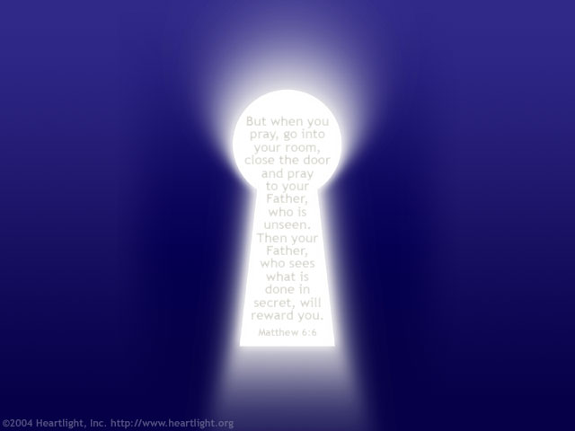

As I write this we are reading in our Women’s Study Group The Grace of Les Miserables by Rawle and this passage makes me think about Hugo’s antipathy toward religion, probably as a result of seeing too many religious people who didn’t seem to want to deal with the social issues that surrounded Hugo in Paris. Despite turning his back on organized religion, Hugo prayed twice a day until his death and his will is a testament to his beliefs:

“I leave 50,000 francs to the poor. I wish to be buried in their hearse. I refuse [funeral] orations from all churches. I ask all souls for a prayer.
I believe in God.”

He also wrote…
“To give thanks in solitude is enough. Thanksgiving has wings and goes where it must go. Your prayer knows much more about it than you do. “

His Les Miserables is filled with such stirring reflections of grace and mercy that it has inspired musicals, art and religious studies. His writing has changed people’s hearts and he helped to change a nation. While he was by no means a saint (though he is worshipped as one in the Vietnamese religion of Cao Dai), he did live a life of daily devotion and action to relieve the suffering of the poor and powerless. His heart was always with the poor, even while he achieved great success.
Where is our heart? Where does our treasure lie? Lent is the perfect time to reflect on what matters to us and if we are focused on the right things. If you haven’t read Les Miserables I encourage you to pick it up and read it during Lent and join us at Woman’s Study Group if you can.

-Suzanne Nash

February 27th - Thursday after Ash Wednesday
Luke 9:18–25
Once when Jesus was praying alone, with only the disciples near him, he asked them, “Who do the crowds say that I am?” They answered, “John the Baptist; but others, Elijah; and still others, that one of the ancient prophets has arisen.” He said to them, “But who do you say that I am?” Peter answered, “The Messiah of God.”
He sternly ordered and commanded them not to tell anyone, saying, “The Son of Man must undergo great suffering, and be rejected by the elders, chief priests, and scribes, and be killed, and on the third day be raised.”
Then he said to them all, “If any want to become my followers, let them deny themselves and take up their cross daily and follow me. For those who want to save their life will lose it, and those who lose their life for my sake will save it. What does it profit them if they gain the whole world, but lose or forfeit themselves?”

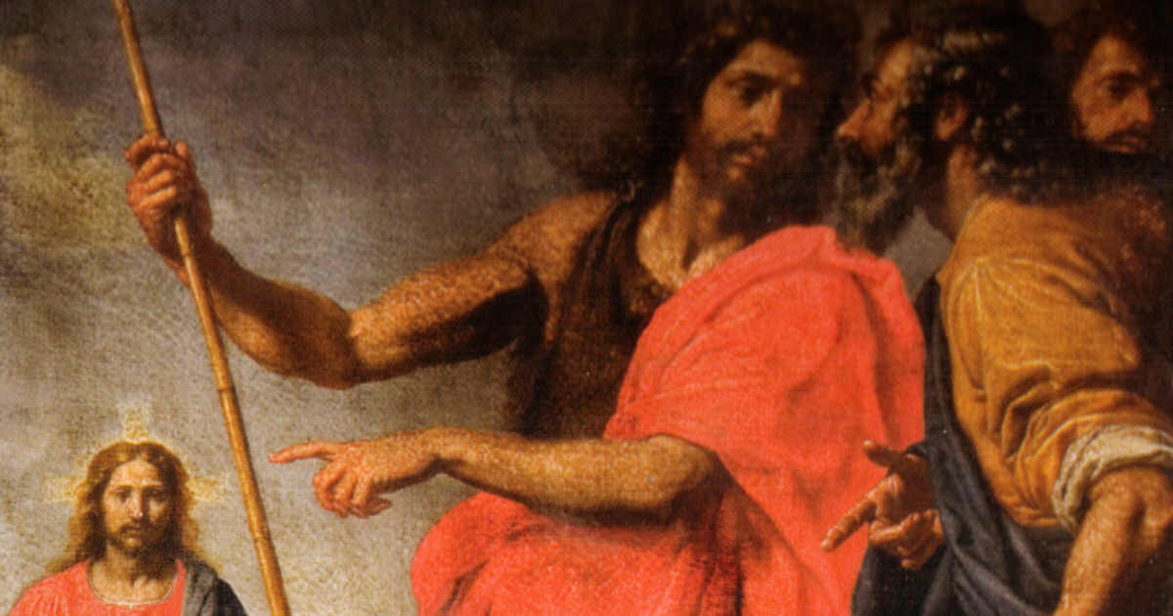

Ottavio Vannini (1585-c. 1643) - Giovanni Piccirillo (a cura di), La chiesa dei Santi Michele e Gaetano

My beloved, who do you say that I am?
Do you believe that I AM The Pure Lamb?

Are you blinded or do you truly see
That you could become an image of Me?

Who do you really think I am, Dear one?
Do you think when I died my work was done?

Do you believe you are my My hands and My feet
And that I guide you from Heaven's Holy Seat?

If you truly know my love belongs to you
It will affect what you think, say and do.

For if you truly love Me and follow my ways
You'll find My Peace will bless your days.

Who Am I to you? I really want to know.
Do you know I lift you when you are low?

Can you imagine the expanse of my love
That spans eternity, earth to heav'n above?

I AM the GOD who willed you to be here
Before anything that ever came to being;
My child, I AM yours, you are Mine
I've removed the scales and you are seeing.

Now ~Who do you say that I Am?
Do you now believe
I AM
The Pure Lamb?

-Carmella Patterson

February 28th- Friday after Ash Wednesday

Matthew 9:10–17
As Jesus sat at dinner in the house, many tax collectors and sinners came and were sitting with him and his disciples. When the Pharisees saw this, they said to his disciples, “Why does your teacher eat with tax collectors and sinners?” But when he heard this, he said, “Those who are well have no need of a physician, but those who are sick. Go and learn what this means, ‘I desire mercy, not sacrifice.’ For I have come to call not the righteous but sinners.”
Then the disciples of John came to him, saying, “Why do we and the Pharisees fast often, but your disciples do not fast?” And Jesus said to them, “The wedding guests cannot mourn as long as the bridegroom is with them, can they? The days will come when the bridegroom is taken away from them, and then they will fast. No one sews a piece of unshrunk cloth on an old cloak, for the patch pulls away from the cloak, and a worse tear is made. Neither is new wine put into old wineskins; otherwise, the skins burst, and the wine is spilled, and the skins are destroyed; but new wine is put into fresh wineskins, and so both are preserved.

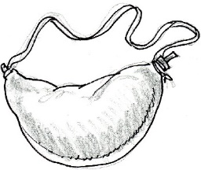

New wine requires new wineskins. It’s the only way to keep both the wine and the skin preserved. Here is Jesus in this story hanging out with what religious leaders might have described as a “basket of deplorables”. Further, he’s telling the leaders “I desire mercy, not sacrifice”. His message of mercy is new wine, and he must be busy helping those tax collectors and sinners create new skins to receive this message.

But isn’t this message of mercy new wine for the Pharisees, too? How must the Pharisees adapt to receive this message?

“A bag of tools”, by R. L. Sharpe

Isn’t it strange
That princes and kings,
And clown that caper
In sawdust rings,
And common people
Like you and me
Are builders for eternity?

Each is given a bag of tools,
A shapeless mass,
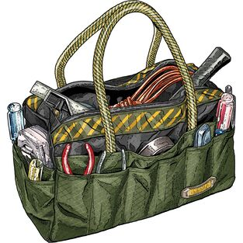
A book of rules;
And each must make--
Ere life is flown--
A stumbling block
Or a steppingstone.

Mary Leslie Tise

February 29th- Saturday after Ash Wednesday

Luke 5:27–32
After healing the paralyzed man, Jesus went out and saw a tax collector named Levi, sitting at the tax booth; and he said to him, “Follow me.” And he got up, left everything, and followed him.
Then Levi gave a great banquet for him in his house; and there was a large crowd of tax collectors and others sitting at the table with them. The Pharisees and their scribes were complaining to his disciples, saying, “Why do you eat and drink with tax collectors and sinners?” Jesus answered, “Those who are well have no need of a physician, but those who are sick; I have come to call not the righteous but sinners to repentance.”

Of the characters in this story, with which would you best identify? I suspect that most of us would prefer the role of the tax collector, who had the satisfaction of hosting Jesus and receiving His grace and comfort. Indeed, one would like to think that we would follow Jesus willingly at his invitation and, like the tax collector, would demonstrate our gratitude and loyalty by such a donation as the great banquet.
But I’m afraid that too often we unwittingly imitate the Pharisees and their scribes in passing judgement on someone we see as a “sinner,” or someone of a different opinion or persuasion from ours. We too readily see ourselves as those who are well, having no need of a physician. And perhaps we may also go further and, again like the Pharisees and scribes, complain about what we deem unfair in the acceptance of such apparent sinners.
Let us always be open to our Lord’s invitation to “follow me,” regardless of the direction and the cost.

-Corky Shackelford

March 1st - First Sunday in Lent
Matthew 4:1-11
Jesus was led up by the Spirit into the wilderness to be tempted by the devil. He fasted forty days and forty nights, and afterwards he was famished. The tempter came and said to him, “If you are the Son of God, command these stones to become loaves of bread.” But he answered, “It is written,
‘One does not live by bread alone,
but by every word that comes from the mouth of God.’”
Then the devil took him to the holy city and placed him on the pinnacle of the temple, saying to him, “If you are the Son of God, throw yourself down; for it is written,
‘He will command his angels concerning you,’
and ‘On their hands they will bear you up,
so that you will not dash your foot against a stone.’”
Jesus said to him, “Again it is written, ‘Do not put the Lord your God to the test.’”
Again, the devil took him to a very high mountain and showed him all the kingdoms of the world and their splendor; and he said to him, “All these I will give you, if you will fall down and worship me.” Jesus said to him, “Away with you, Satan! for it is written,
‘Worship the Lord your God,
and serve only him.’”
Then the devil left him, and suddenly angels came and waited on him.
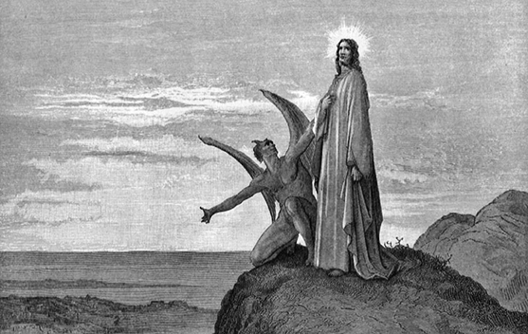

This passage, the account of Jesus being tempted by the devil, contains some of the most vivid imagery in the Gospels, cites other well-known bible passages, and contains (for me) some enigmatic paradoxes.
First, are the descriptions of the temptations literal or figurative. Jesus is described as “famished,” having fasted forty days and nights. Was he imagining his encounter with the devil? The devil leads Jesus “to a very high mountain [to show] him all the kingdoms of the world.” Surely, such a high place could not really exist!
Second, Jesus is “led up by the Spirit…to be tempted.” Is this Spirit God Himself, putting Jesus to the test? If so, it won’t be the final test (as at the crucifixion)? Yet, Jesus rebuffs the devil after the second temptation: “Do not put the Lord your God to the test.” But isn’t this God testing God?
Finally, after the devil leaves, “angels came and waited on [Jesus].” Does the same Spirit who led Jesus to be tested now rescue him via angelic intervention? Without temptation, and successful rebuke of it, is there no salvation?
Jesus’ own instructions to pray include the phrase: “lead us not into temptation, but deliver us from evil.” Evil does exist in God’s world, and, in fact, it was God who led Jesus “into temptation.” Just as Jesus did, we pray for God’s help to overcome temptation in all its forms.

-Michael Latsko

March 2nd - Monday in the First Week of Lent
Matthew 25:31–46
Jesus said, “When the Son of Man comes in his glory, and all the angels with him, then he will sit on the throne of his glory. All the nations will be gathered before him, and he will separate people one from another as a shepherd separates the sheep from the goats, and he will put the sheep at his right hand and the goats at the left. Then the king will say to those at his right hand, ‘Come, you that are blessed by my Father, inherit the kingdom prepared for you from the foundation of the world; for I was hungry and you gave me food, I was thirsty and you gave me something to drink, I was a stranger and you welcomed me, I was naked and you gave me clothing, I was sick and you took care of me, I was in prison and you visited me.’ Then the righteous will answer him, ‘Lord, when was it that we saw you hungry and gave you food, or thirsty and gave you something to drink? And when was it that we saw you a stranger and welcomed you, or naked and gave you clothing? And when was it that we saw you sick or in prison and visited you?’ And the king will answer them, ‘Truly I tell you, just as you did it to one of the least of these who are members of my family, you did it to me.’ Then he will say to those at his left hand, ‘You that are accursed, depart from me into the eternal fire prepared for the devil and his angels; for I was hungry and you gave me no food, I was thirsty and you gave me nothing to drink, I was a stranger and you did not welcome me, naked and you did not give me clothing, sick and in prison and you did not visit me.’ Then they also will answer, ‘Lord, when was it that we saw you hungry or thirsty or a stranger or naked or sick or in prison, and did not take care of you?’ Then he will answer them, ‘Truly I tell you, just as you did not do it to one of the least of these, you did not do it to me.’ And these will go away into eternal punishment, but the righteous into eternal life.”

I was hungry …
And you formed humanities groups to discuss my hunger.
I was imprisoned …
And you crept off quietly to your church and prayed for my release.
I was naked …
And in your mind you debated the morality of my appearance.
I was sick …
And you knelt and thanked God for your health.
I was homeless …
And you preached to me of the spiritual shelter of the love of God.
I was lonely …
And you left me alone to pray for me.
You seem so holy, so close to God …
But I am still hungry … and lonely … and cold …
~ author unknown ~

March 3rd- Tuesday in the First Week of Lent
Matthew 6:7–15
Jesus said, “When you are praying, do not heap up empty phrases as the Gentiles do; for they think that they will be heard because of their many words. Do not be like them, for your Father knows what you need before you ask him.
“Pray then in this way:
Our Father in heaven,
hallowed be your name.
Your kingdom come.
Your will be done,
on earth as it is in heaven.
Give us this day our daily bread.
And forgive us our debts,
as we also have forgiven our debtors.
And do not bring us to the time of trial,
but rescue us from the evil one.
For if you forgive others their trespasses, your heavenly Father will also forgive you; but if you do not forgive others, neither will your Father forgive your trespasses.”

March 4th- Wednesday in the First Week of Lent
Luke 11:29–32
When the crowds were increasing, Jesus began to say, “This generation is an evil generation; it asks for a sign, but no sign will be given to it except the sign of Jonah. For just as Jonah became a sign to the people of Nineveh, so the Son of Man will be to this generation. The queen of the South will rise at the judgment with the people of this generation and condemn them, because she came from the ends of the earth to listen to the wisdom of Solomon, and see, something greater than Solomon is here! The people of Nineveh will rise up at the judgment with this generation and condemn it, because they repented at the proclamation of Jonah, and see, something greater than Jonah is here!”

Jesus demonstrates his frustration with the gathering crowd that is demanding a sign to convince them that he is the one they have been waiting for. The crowd could not or would not accept the mere presence of Jesus and all of the miracles he performed as their sign of the messiah.
So, too, our generation is a “show me” generation. We have little time to believe in something that is not clearly evident to us. I do believe Jesus might also scold today’s generation. All too often we turn to God and ask for a sign to prove he is listening to our prayers when we are in need. We must realize that perhaps our prayers may not be answered in a way we think they should be, but that God answers them in many ways. We need to be prepared for God’s surprises.
I found a meditation from Pope Francis (Morning Meditation, October 13, 2014) that seems to be worthy of reflection during this Lenten season and offers further reflection on this passage of Luke. Ask yourself the following questions:
“Am I attached to my things, to my ideas, closed ?”
“Am I open to the God of surprises?”
“Am I a stationary person or a person on a journey?”
“Do I believe in Jesus Christ and in what he has done, that is, he died, rose again…”
“Do I believe that the journey goes forth toward maturity, toward the manifestation of the glory of the Lord?”
Am I capable of understanding the signs of the times and of being faithful to the voice of the Lord, that is manifest in them?

-Micki Adams

March 5th- Thursday in the First Week of Lent
Matthew 7:7–12
Jesus said, “Ask, and it will be given you; search, and you will find; knock, and the door will be opened for you. For everyone who asks receives, and everyone who searches finds, and for everyone who knocks, the door will be opened. Is there anyone among you who, if your child asks for bread, will give a stone? Or if the child asks for a fish, will give a snake? If you then, who are evil, know how to give good gifts to your children, how much more will your Father in heaven give good things to those who ask him!
“In everything do to others as you would have them do to you; for this is the law and the prophets.”

Ask and it will be given you. This brings to mind the story of King Midas who wanted much gold. He asked that everything he touched would turn to gold. This was granted and he delighted in touching things and getting gold. This was fine until he wanted to eat. The food turned to gold. When his daughter came in, he kissed her and she did likewise. I think we need to be careful what we ask for. We are given free will and can chose to ask for things that will be good for us. Also, we should search for good things and be careful in choosing which doors to knock on.
-Mary Aston Shackelford

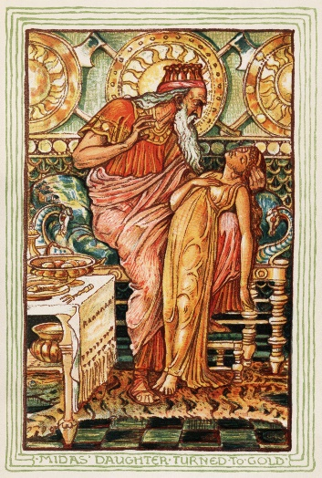

March 6th - Friday in the First Week of Lent
Matthew 5:20–26
Jesus said, “I tell you, unless your righteousness exceeds that of the scribes and Pharisees, you will never enter the kingdom of heaven.
“You have heard that it was said to those of ancient times, ‘You shall not murder’; and ‘whoever murders shall be liable to judgment.’ But I say to you that if you are angry with a brother or sister, you will be liable to judgment; and if you insult a brother or sister, you will be liable to the council; and if you say, ‘You fool,’ you will be liable to the hell of fire. So when you are offering your gift at the altar, if you remember that your brother or sister has something against you, leave your gift there before the altar and go; first be reconciled to your brother or sister, and then come and offer your gift. Come to terms quickly with your accuser while you are on the way to court with him, or your accuser may hand you over to the judge, and the judge to the guard, and you will be thrown into prison. Truly I tell you, you will never get out until you have paid the last penny.”

People have a hard time letting go of their suffering. Out of a fear of the unknown, they prefer suffering that is familiar.
The practice of peace and reconciliation is one of the most vital and artistic of human actions.
Thich Nhat Hanh

March 7th - Saturday in the First Week of Lent
Matthew 5:43–48
Jesus said, “You have heard that it was said, ‘You shall love your neighbor and hate your enemy.’ But I say to you, Love your enemies and pray for those who persecute you, so that you may be children of your Father in heaven; for he makes his sun rise on the evil and on the good, and sends rain on the righteous and on the unrighteous. For if you love those who love you, what reward do you have? Do not even the tax collectors do the same? And if you greet only your brothers and sisters, what more are you doing than others? Do not even the Gentiles do the same? Be perfect, therefore, as your heavenly Father is perfect.”

Love Your Enemies
I sometimes quite boldly berate
those folks who cut lines or tailgate.
Then I'm taken aback
by the patience I lack.
Grant me GRACE to love - and not hate.

-Lynn Baker

March 8th – Second Sunday in Lent

John 3:1-17
There was a Pharisee named Nicodemus, a leader of the Jews. He came to Jesus by night and said to him, “Rabbi, we know that you are a teacher who has come from God; for no one can do these signs that you do apart from the presence of God.” Jesus answered him, “Very truly, I tell you, no one can see the kingdom of God without being born from above.” Nicodemus said to him, “How can anyone be born after having grown old? Can one enter a second time into the mother’s womb and be born?” Jesus answered, “Very truly, I tell you, no one can enter the kingdom of God without being born of water and Spirit. What is born of the flesh is flesh, and what is born of the Spirit is spirit. Do not be astonished that I said to you, ‘You must be born from above.’ The wind blows where it chooses, and you hear the sound of it, but you do not know where it comes from or where it goes. So it is with everyone who is born of the Spirit.” Nicodemus said to him, “How can these things be?” Jesus answered him, “Are you a teacher of Israel, and yet you do not understand these things?
“Very truly, I tell you, we speak of what we know and testify to what we have seen; yet you do not receive our testimony. If I have told you about earthly things and you do not believe, how can you believe if I tell you about heavenly things? No one has ascended into heaven except the one who descended from heaven, the Son of Man. And just as Moses lifted up the serpent in the wilderness, so must the Son of Man be lifted up, that whoever believes in him may have eternal life.
“For God so loved the world that he gave his only Son, so that everyone who believes in him may not perish but may have eternal life.
“Indeed, God did not send the Son into the world to condemn the world, but in order that the world might be saved through him.”

Today is the 2nd year that my husband , John, will celebrate his birthday in Heaven. What an incredible love he left to me to get me through this world, until I join him.
Today’s scripture is probably the most well known, the most ubiquitous. It is the first scripture a new Believer learns and memorizes. John 3:16 can be found on jewelry, billboards, bumper stickers, tattoos, as well as written on walls, carved on rocks and tombstones, known in all languages and religions, professed and preached and used as a life standard, but what does it mean? What does it really mean? Scholars and theologians have debated for centuries. It sure means many things to many people.
For me…. "God so loved the world, His World, that He gave, sacrificed, his only Son, only Beloved, so that everyone who believes, who acknowledges the Truth, in Him, may not perish, may not live in eternal separation, but may have eternal life, life with the infinite love of God. "
Who among us would or could do the same? God's promise is so very comforting to know, to truly know, where I will go when I die, when I leave this world, His World, to go to Eternal Love.
There is additional love that God gives to us on this side of Eternity, I believe, that allows us to fulfill His Mission in His World.
For God so loved...that He gave us friends.
For God so loved…that He gave us the ability to love and be loved
For God so loved…that He gave us the opportunity to choose good over evil.
For God so loved…that He shines His Light in our darkest places.
For God so loved…that He gave us the example, Christ.
For God so loved…that He gave us the ability to care for and steward His Creation.
For God so loved…that He gave us the freedom to sin, knowing that we could be redeemed and forgiven.
For God so loved…that He lets us fall, while giving us the courage to get up again and again.
For God so loved…that He gave us faith in the face of doubt.
For God so loved…that He brings peace in the storms of our life.
For God so loved...that He gave us music and art to translate His Love
For God so loved... that He gave Himself to a fallible creation.
For God so loved…that He gave us the Bible and this is His Word, and he always keeps His Word, His Promise.

Thanks be to God.
-Mary Loose Deviney

March 9th - Monday in the Second Week of Lent
Luke 6:27–38
Jesus said, “I say to you that listen, Love your enemies, do good to those who hate you, bless those who curse you, pray for those who abuse you. If anyone strikes you on the cheek, offer the other also; and from anyone who takes away your coat do not withhold even your shirt. Give to everyone who begs from you; and if anyone takes away your goods, do not ask for them again. Do to others as you would have them do to you.
“If you love those who love you, what credit is that to you? For even sinners love those who love them. If you do good to those who do good to you, what credit is that to you? For even sinners do the same. If you lend to those from whom you hope to receive, what credit is that to you? Even sinners lend to sinners, to receive as much again. But love your enemies, do good, and lend, expecting nothing in return. Your reward will be great, and you will be children of the Most High; for he is kind to the ungrateful and the wicked. Be merciful, just as your Father is merciful.
“Do not judge, and you will not be judged; do not condemn, and you will not be condemned. Forgive, and you will be forgiven; give, and it will be given to you. A good measure, pressed down, shaken together, running over, will be put into your lap; for the measure you give will be the measure you get back.”

This passage is filled with lessons learned as children and tried as adults. Jesus knew it was human nature to hate your enemies, strike back when provoked and expect reciprocity for good deeds. These knee-jerk reactions often lead to short-term solutions and unwanted conclusions.
May we strive to live each day by The Golden Rule; Do to others as you would have them do to you.

People are often unreasonable and self-centered.
Forgive them anyway.

If you are kind, people may accuse you of ulterior motives.
Be kind anyway.

If you are honest, people may cheat you.
Be honest anyway.

If you find happiness, people may be jealous.
Be happy anyway.

The good you do today may be forgotten tomorrow.
Do good anyway.

Give the world the best you have, and it may never be enough.
Give your best anyway.

Mother Teresa

-Sharon Merrick

March 10th - Tuesday in the Second week of Lent
Matthew 23:1–12
Jesus said to the crowds and to his disciples, “The scribes and the Pharisees sit on Moses’ seat; therefore, do whatever they teach you and follow it; but do not do as they do, for they do not practice what they teach. They tie up heavy burdens, hard to bear, and lay them on the shoulders of others; but they themselves are unwilling to lift a finger to move them. They do all their deeds to be seen by others; for they make their phylacteries broad and their fringes long. They love to have the place of honor at banquets and the best seats in the synagogues, and to be greeted with respect in the marketplaces, and to have people call them rabbi. But you are not to be called rabbi, for you have one teacher, and you are all students. And call no one your father on earth, for you have one Father—the one in heaven. Nor are you to be called instructors, for you have one instructor, the Messiah. The greatest among you will be your servant. All who exalt themselves will be humbled, and all who humble themselves will be exalted.

On the Mount of Olives Jesus spoke about hypocrisy among the Pharisees and the scribes when he talked to multitudes weighed down by daily problems and the burdensome requirements of religious law. He criticized leaders who exalted themselves and cautioned against braggarts who laid “heavy burdens, grievous to be borne” on men’s shoulders, “but do not lift a finger” to carry the load.

Today when we meet such onerous people, we can take heart in a familiar sight—a flock of birds flying overhead in classic V-formation. Modern studies of migratory northern bald ibises have shown that the aerodynamics of V-formation saves energy by sharing the uplift from the wings of the bird flying before. The birds divide the burden of journeys by trading places. When the lead bird in the V-formation tires, he drops back and another takes his place. This practice, called reciprocal altruism, offers safety for the entire flock on long migratory hauls.
Jesus told his followers to observe—but not to follow—the hypocritical scribes and Pharisees, “who wish their deeds to be seen by others.” There was, he suggested, a better way. In the end, he reminds us, humility and exaltation will trade places.

-Janet Carmichael

March 11th - Wednesday in the Second week of Lent
Matthew 20:17–28
While Jesus was going up to Jerusalem, he took the twelve disciples aside by themselves, and said to them on the way, “See, we are going up to Jerusalem, and the Son of Man will be handed over to the chief priests and scribes, and they will condemn him to death; then they will hand him over to the Gentiles to be mocked and flogged and crucified; and on the third day he will be raised.”
Then the mother of the sons of Zebedee came to him with her sons, and kneeling before him, she asked a favor of him. And he said to her, “What do you want?” She said to him, “Declare that these two sons of mine will sit, one at your right hand and one at your left, in your kingdom.” But Jesus answered, “You do not know what you are asking. Are you able to drink the cup that I am about to drink?” They said to him, “We are able.” He said to them, “You will indeed drink my cup, but to sit at my right hand and at my left, this is not mine to grant, but it is for those for whom it has been prepared by my Father.”
When the ten heard it, they were angry with the two brothers. But Jesus called them to him and said, “You know that the rulers of the Gentiles lord it over them, and their great ones are tyrants over them. It will not be so among you; but whoever wishes to be great among you must be your servant, and whoever wishes to be first among you must be your slave; just as the Son of Man came not to be served but to serve, and to give his life a ransom for many.”

Dear Lord,

Continue to renew in me a steadfast heart of following after You. Disrupt the ugly parts of myself, the selfish, prideful, judgmental elements of myself, which hinder the emergence of the Spirit. Pour Your Spirit into me and fill me to the brim. Pour me out that I may be filled up more with You! Less of me, and more of You, always. Thank You for Your patience with me, especially when I truly do not want to obey Your leading, or when I struggle with serving in love. However, I want to have a servant’s heart. Help me to want to serve in love to develop it.

In Jesus’ name, Amen.

March 12th - Thursday in the Second Week of Lent
Luke 16:19–31
Jesus said, "There was a rich man who was dressed in purple and fine linen and who feasted sumptuously every day. And at his gate lay a poor man named Lazarus, covered with sores, who longed to satisfy his hunger with what fell from the rich man's table; even the dogs would come and lick his sores. The poor man died and was carried away by the angels to be with Abraham. The rich man also died and was buried. In Hades, where he was being tormented, he looked up and saw Abraham far away with Lazarus by his side. He called out, `Father Abraham, have mercy on me, and send Lazarus to dip the tip of his finger in water and cool my tongue; for I am in agony in these flames.' But Abraham said, `Child, remember that during your lifetime you received your good things, and Lazarus in like manner evil things; but now he is comforted here, and you are in agony. Besides all this, between you and us a great chasm has been fixed, so that those who might want to pass from here to you cannot do so, and no one can cross from there to us.' He said, `Then, father, I beg you to send him to my father's house-- for I have five brothers-- that he may warn them, so that they will not also come into this place of torment.' Abraham replied, `They have Moses and the prophets; they should listen to them.' He said, `No, father Abraham; but if someone goes to them from the dead, they will repent.' He said to him, `If they do not listen to Moses and the prophets, neither will they be convinced even if someone rises from the dead.'"

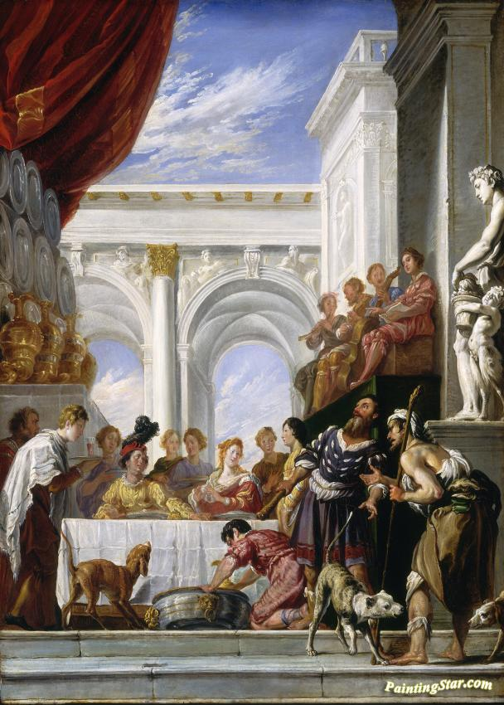

The Parable of Lazarus and the Rich Man

By Domenico Fetti

March 13th - Friday in the Second Week of Lent
Matthew 21:33–43
Jesus said, "Listen to another parable. There was a landowner who planted a vineyard, put a fence around it, dug a wine press in it, and built a watchtower. Then he leased it to tenants and went to another country. When the harvest time had come, he sent his slaves to the tenants to collect his produce. But the tenants seized his slaves and beat one, killed another, and stoned another. Again he sent other slaves, more than the first; and they treated them in the same way. Finally he sent his son to them, saying, `They will respect my son.' But when the tenants saw the son, they said to themselves, `This is the heir; come, let us kill him and get his inheritance.' So they seized him, threw him out of the vineyard, and killed him. Now when the owner of the vineyard comes, what will he do to those tenants?" They said to him, "He will put those wretches to a miserable death, and lease the vineyard to other tenants who will give him the produce at the harvest time."
Jesus said to them, "Have you never read in the scriptures:
`The stone that the builders rejected
has become the cornerstone;
this was the Lord's doing,
and it is amazing in our eyes'?
“Therefore I tell you, the kingdom of God will be taken away from you and given to a people that produces the fruits of the kingdom.”

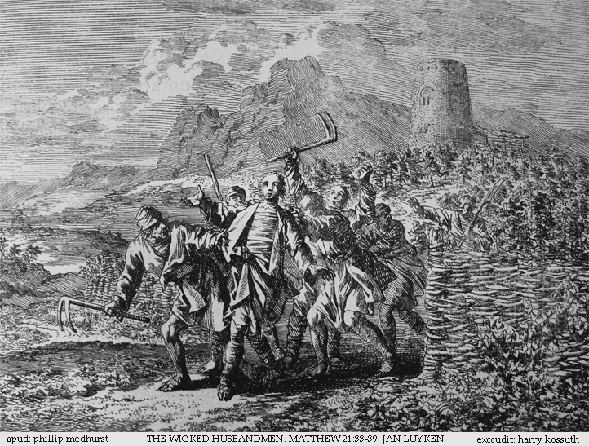

Sharon Page, a Professor Emerita at Wesley Theological Seminary, describes this passage as a “puzzling parable.” I agree, and so I’m borrowing from commentary by others who have analyzed this parable, which also appears in the gospels of Mark and Luke.

Jesus addressed this parable to chief priests and elders who questioned His authority. Some commentators liken the landowner to God, the vineyard to Israel, the tenants to Israel’s people or religious leaders, the slaves to the prophets, and the landowner’s son to Jesus.

The prophets Zechariah and Uriah were killed, and Jeremiah was beaten. The religious leaders and others claimed to obey God, yet they rejected His messengers. They also supported the crucifixion of Jesus, the “son” of the “landowner” in this parable. Jesus tells His audience that the kingdom of God will be taken away from them and given to those who follow Him, just as the vineyard would be taken away from the disobedient tenants and given to other tenants. The rejected stone (Jesus) will become the symbolic chief cornerstone of the church, as referenced in Ephesians 2:20. Jesus urges us to live a life of obedience and not to reject His teachings.

-Fred Shackelford

March 14th -Saturday in the Second Week of Lent
Luke 15:11–32
Jesus said, “There was a man who had two sons. The younger of them said to his father, ‘Father, give me the share of the property that will belong to me.’ So he divided his property between them. A few days later the younger son gathered all he had and traveled to a distant country, and there he squandered his property in dissolute living. When he had spent everything, a severe famine took place throughout that country, and he began to be in need. So he went and hired himself out to one of the citizens of that country, who sent him to his fields to feed the pigs. He would gladly have filled himself with the pods that the pigs were eating; and no one gave him anything. But when he came to himself he said, ‘How many of my father’s hired hands have bread enough and to spare, but here I am dying of hunger! I will get up and go to my father, and I will say to him, “Father, I have sinned against heaven and before you; I am no longer worthy to be called your son; treat me like one of your hired hands.”’ So he set off and went to his father. But while he was still far off, his father saw him and was filled with compassion; he ran and put his arms around him and kissed him. Then the son said to him, ‘Father, I have sinned against heaven and before you; I am no longer worthy to be called your son.’ But the father said to his slaves, ‘Quickly, bring out a robe—the best one—and put it on him; put a ring on his finger and sandals on his feet. And get the fatted calf and kill it, and let us eat and celebrate; for this son of mine was dead and is alive again; he was lost and is found!’ And they began to celebrate.
“Now his elder son was in the field; and when he came and approached the house, he heard music and dancing. He called one of the slaves and asked what was going on. He replied, ‘Your brother has come, and your father has killed the fatted calf, because he has got him back safe and sound.’ Then he became angry and refused to go in. His father came out and began to plead with him. But he answered his father, ‘Listen! For all these years I have been working like a slave for you, and I have never disobeyed your command; yet you have never given me even a young goat so that I might celebrate with my friends. But when this son of yours came back, who has devoured your property with prostitutes, you killed the fatted calf for him!’ Then the father said to him, ‘Son, you are always with me, and all that is mine is yours. But we had to celebrate and rejoice, because this brother of yours was dead and has come to life; he was lost and has been found.’”

How often do we feel that life is unfair? We work hard and do our best and then turn around to see someone else who doesn’t seem to deserve favors, getting the best of everything. Yes, perhaps life isn’t fair….if we are always comparing our life and circumstances to others. But do we look at the blessings we have and recognize them for what they are? The comforts of love and family? The simple pleasures that are ours every single day? Comparing our lot to others is the surest way to create discomfort and resentment in our lives, and then we are more like the young man choosing to waste what God has given us…then we are the prodigal son, who needs to recognize the life that we once took for granted. Then we can turn back to God and return, showing gratitude and appreciation for our unique and beautiful relationship to our Father, without looking to our left or right to see if anyone else has more than we do. For God loves us all and welcomes us with love and open arms if we only are willing to return home.

-Suzanne Nash

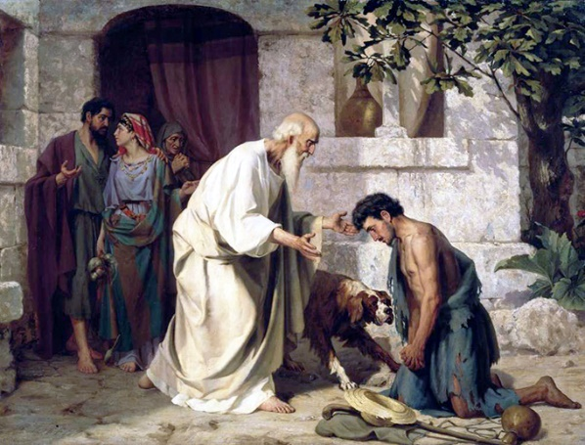

March 15th - Third Sunday in Lent
John 4:5-42
Jesus came to a Samaritan city called Sychar, near the plot of ground that Jacob had given to his son Joseph. Jacob’s well was there, and Jesus, tired out by his journey, was sitting by the well. It was about noon.
A Samaritan woman came to draw water, and Jesus said to her, “Give me a drink.” (His disciples had gone to the city to buy food.) The Samaritan woman said to him, “How is it that you, a Jew, ask a drink of me, a woman of Samaria?” (Jews do not share things in common with Samaritans.) Jesus answered her, “If you knew the gift of God, and who it is that is saying to you, ‘Give me a drink,’ you would have asked him, and he would have given you living water.” The woman said to him, “Sir, you have no bucket, and the well is deep. Where do you get that living water? Are you greater than our ancestor Jacob, who gave us the well, and with his sons and his flocks drank from it?” Jesus said to her, “Everyone who drinks of this water will be thirsty again, but those who drink of the water that I will give them will never be thirsty. The water that I will give will become in them a spring of water gushing up to eternal life.” The woman said to him, “Sir, give me this water, so that I may never be thirsty or have to keep coming here to draw water.”
Jesus said to her, “Go, call your husband, and come back.” The woman answered him, “I have no husband.” Jesus said to her, “You are right in saying, ‘I have no husband’; for you have had five husbands, and the one you have now is not your husband. What you have said is true!” The woman said to him, “Sir, I see that you are a prophet. Our ancestors worshiped on this mountain, but you say that the place where people must worship is in Jerusalem.” Jesus said to her, “Woman, believe me, the hour is coming when you will worship the Father neither on this mountain nor in Jerusalem. You worship what you do not know; we worship what we know, for salvation is from the Jews. But the hour is coming, and is now here, when the true worshipers will worship the Father in spirit and truth, for the Father seeks such as these to worship him. God is spirit, and those who worship him must worship in spirit and truth.” The woman said to him, “I know that Messiah is coming” (who is called Christ). “When he comes, he will proclaim all things to us.” Jesus said to her, “I am he, the one who is speaking to you.”
Just then his disciples came. They were astonished that he was speaking with a woman, but no one said, “What do you want?” or, “Why are you speaking with her?” Then the woman left her water jar and went back to the city. She said to the people, “Come and see a man who told me everything I have ever done! He cannot be the Messiah, can he?” They left the city and were on their way to him.
Meanwhile the disciples were urging him, “Rabbi, eat something.” But he said to them, “I have food to eat that you do not know about.” So the disciples said to one another, “Surely no one has brought him something to eat?” Jesus said to them, “My food is to do the will of him who sent me and to complete his work. Do you not say, ‘Four months more, then comes the harvest’? But I tell you, look around you, and see how the fields are ripe for harvesting. The reaper is already receiving wages and is gathering fruit for eternal life, so that sower and reaper may rejoice together. For here the saying holds true, ‘One sows and another reaps.’ I sent you to reap that for which you did not labor. Others have labored, and you have entered into their labor.”
Many Samaritans from that city believed in him because of the woman’s testimony, “He told me everything I have ever done.” So when the Samaritans came to him, they asked him to stay with them; and he stayed there two days. And many more believed because of his word. They said to the woman, “It is no longer because of what you said that we believe, for we have heard for ourselves, and we know that this is truly the Savior of the world.”

The Samaritan Woman

By Marina Zakary

I am the woman Christ met at the well

My life was a mess, it was like living in hell

Until I came across a man like no other

I was a Samaritan and He was a Jew but I felt like his brother

He asked me for a drink from the well so I filled my cup

He spoke of me and my life and I listened up

He knew all about me and my life full of sin

He knew the shambles that my relationships have been

He said “Drink of my living water and you will never thirst”

You can turn your life around even at your worst

My heavenly and living water will set you free

Your bonds will break just believe in Me

He spoke to me with compassion saying “I am the One.

I am the Messiah, Christ, God’s only Son”

His Father is sitting on heaven’s throne above

Looked down on his people and the world with a heart full of love

I immediately left my water pot and went away

Realising how far I have gone astray

I was struggling with sin, unworthy and weak

But His gentleness changed me and now heaven I seek

I journeyed along and rushed into town

To tell the people about my smile and joy that once was a frown

People gathered around, I said, “The Messiah has come!

He came down to earth to save all people, not just some”

I went to the well as reject and as a woman full of sin

I returned with a full cup, and I had Jesus within

I have turned to Christ and His will; He is worthy of all praise

Therefore I will never thirst again for the rest of my days

March 16th - Monday in the Third Week of Lent

Luke 4:23–30
In the synagogue at Nazareth, Jesus said to them, "Doubtless you will quote to me this proverb, 'Doctor, cure yourself!' And you will say, 'Do here also in your hometown the things that we have heard you did at Capernaum.'" And he said, "Truly I tell you, no prophet is accepted in the prophet's hometown. But the truth is, there were many widows in Israel in the time of Elijah, when the heaven was shut up three years and six months, and there was a severe famine over all the land; yet Elijah was sent to none of them except to a widow at Zarephath in Sidon. There were also many lepers in Israel in the time of the prophet Elisha, and none of them was cleansed except Naaman the Syrian." When they heard this, all in the synagogue were filled with rage. They got up, drove him out of the town, and led him to the brow of the hill on which their town was built, so that they might hurl him off the cliff. But he passed through the midst of them and went on his way.

Can you imagine having Jesus in your midst? A hometown hero who his one time neighbors run out of town and attempt to throw off a cliff? Why?? Because he had not returned to them to heal and perform miracles for them. I mean, after all…this was his hometown, he owed them something, right? Is it ok for a town to feel they are owed something by someone who has been born there? Is there a sense of ownership? We do it everyday. We feel that because we have a relationship with someone we have a greater right to benefit from that relationship. Love is about giving not taking. Raising a child or nurturing someone is in itself a reward and to love someone truly is to expect nothing in return. Do we model this behavior personally?

Lent is the perfect time to reflect on how we demonstrate our love and nurturing spirit…both at home and in the world.

-Suzanne Nash

March 17th Tuesday in the Third Week of Lent

Matthew 18:21–35
Peter came and said to Jesus, "Lord, if another member of the church sins against me, how often should I forgive? As many as seven times?" Jesus said to him, "Not seven times, but, I tell you, seventy-seven times.
"For this reason the kingdom of heaven may be compared to a king who wished to settle accounts with his slaves. When he began the reckoning, one who owed him ten thousand talents was brought to him; and, as he could not pay, his lord ordered him to be sold, together with his wife and children and all his possessions, and payment to be made. So the slave fell on his knees before him, saying, `Have patience with me, and I will pay you everything.' And out of pity for him, the lord of that slave released him and forgave him the debt. But that same slave, as he went out, came upon one of his fellow slaves who owed him a hundred denarii; and seizing him by the throat, he said, `Pay what you owe.' Then his fellow slave fell down and pleaded with him, `Have patience with me, and I will pay you.' But he refused; then he went and threw him into prison until he would pay the debt. When his fellow slaves saw what had happened, they were greatly distressed, and they went and reported to their lord all that had taken place. Then his lord summoned him and said to him, `You wicked slave! I forgave you all that debt because you pleaded with me. Should you not have had mercy on your fellow slave, as I had mercy on you?' And in anger his lord handed him over to be tortured until he would pay his entire debt. So my heavenly Father will also do to every one of you, if you do not forgive your brother or sister from your heart."

Lord make me an instrument of Your peace.

Where there is hatred, let me sow love;

Where there is injury, pardon;

Where there is doubt, faith;

Where there is darkness, light;

And where there is sadness, joy.

O Divine Master, grant that I may not

So much as seek to be consoled as to console;

To be understood as to understand,

To be loved as to love,

For it is in giving that we receive,

It is in pardoning that we are pardoned,

And it is in dying that we are born to

eternal life.

-Saint Francis of Assisi

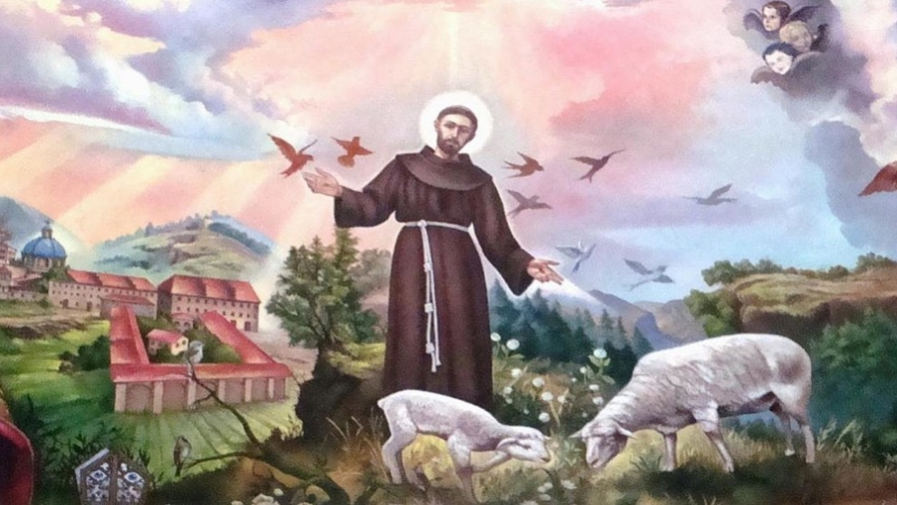

March 18th- Wednesday in the Third Week of Lent

Matthew 5:17–19
Jesus said, “Do not think that I have come to abolish the law or the prophets; I have come not to abolish but to fulfill. For truly I tell you, until heaven and earth pass away, not one letter, not one stroke of a letter, will pass from the law until all is accomplished. Therefore, whoever breaks one of the least of these commandments, and teaches others to do the same, will be called least in the kingdom of heaven; but whoever does them and teaches them will be called great in the kingdom of heaven."
Love Constraining to Obedience
by William Cowper

No strength of nature can suffice
To serve the Lord aright:
And what she has she misapplies,
For want of clearer light.
How long beneath the Law I lay
In bondage and distress;
I toiled the precept to obey,
But toiled without success.
Then, to abstain from outward sin
Was more than I could do;
Now, if I feel its power within,
I feel I hate it too.
Then all my servile works were done
A righteousness to raise;
Now, freely chosen in the Son,
I freely choose His ways.
‘What shall I do,’ was then the word,
‘That I may worthier grow?’
‘What shall I render to the Lord?’
Is my inquiry now.
To see the law by Christ fulfilled
And hear His pardoning voice,
Changes a slave into a child,
And duty into choice.

March 19th Thursday in the Third Week of Lent

Luke 2:41-52
Every year Jesus' parents went to Jerusalem for the festival of the Passover. And when he was twelve years old, they went up as usual for the festival. When the festival was ended and they started to return, the boy Jesus stayed behind in Jerusalem, but his parents did not know it. Assuming that he was in the group of travelers, they went a day's journey. Then they started to look for him among their relatives and friends. When they did not find him, they returned to Jerusalem to search for him. After three days they found him in the temple, sitting among the teachers, listening to them and asking them questions. And all who heard him were amazed at his understanding and his answers. When his parents saw him they were astonished; and his mother said to him, "Child, why have you treated us like this? Look, your father and I have been searching for you in great anxiety." He said to them, "Why were you searching for me? Did you not know that I must be in my Father's house?" But they did not understand what he said to them. Then he went down with them and came to Nazareth, and was obedient to them. His mother treasured all these things in her heart.
And Jesus increased in wisdom and in years, and in divine and human favor.

If you’ve ever been lost or separated from someone, this story will bring back all those panicked feelings. Mary and Joseph drop everything, reschedule their lives, and search for days until they find their son. Jesus, meanwhile, finds his own way back to the temple, asks questions, and seeks answers from the rabbis. Those rabbis, in turn, are amazed at Jesus’ questions and answers.

Everything works out, and everyone is found and reunited, but not in the way or place that anyone expected. Sometimes we are surprised by where we find ourselves. Was God’s hand at work? Is it because we were about “our Father’s business”? If we still feel lost, maybe we haven’t finished our journey yet.

Mary Leslie Tise

March 20th -Friday in the Third Week of Lent

Mark 12:28–34
One of the scribes came near and heard Jesus and the Saducees disputing with one another, and seeing that Jesus answered them well, he asked him, “Which commandment is the first of all?” Jesus answered, “The first is, ‘Hear, O Israel: the Lord our God, the Lord is one; you shall love the Lord your God with all your heart, and with all your soul, and with all your mind, and with all your strength.’ The second is this, ‘You shall love your neighbor as yourself.’ There is no other commandment greater than these.” Then the scribe said to him, “You are right, Teacher; you have truly said that ‘he is one, and besides him there is no other’; and ‘to love him with all the heart, and with all the understanding, and with all the strength,’ and ‘to love one’s neighbor as oneself,’ —this is much more important than all whole burnt offerings and sacrifices.” When Jesus saw that he answered wisely, he said to him, “You are not far from the kingdom of God.” After that no one dared to ask him any question.

Show Me My Neighbor
By Edward O’N. Hoyt

Lord of All Love,
As I step out the door, show me my neighbor.
As I read the news, show me my neighbor.
As I pray, show me my neighbor.
On my left, on my right
Perhaps turning to me right now
Show me my neighbor.

Where my eyes have passed before and then turned away
Show me my neighbor.
Where my ears have heard cries that I have ignored
Show me my neighbor.
As they share a story that is different from my story
Help me to listen as if it is my own.
Show me my neighbor.

And then let me love them
In their joy and in their distress
That their delight be mine
And their pain be mine too.
Let me love them
As completely and mercifully as you love me.
In true solidarity
Singing our songs together until a new song emerges,
Let me love them.

I look up now, Lord. Show me my neighbor.

Amen

March 21st - Saturday in the Third Week of Lent

Luke 18:9–14
Jesus told this parable to some who trusted in themselves that they were righteous and regarded others with contempt: "Two men went up to the temple to pray, one a Pharisee and the other a tax collector. The Pharisee, standing by himself, was praying thus, `God, I thank you that I am not like other people: thieves, rogues, adulterers, or even like this tax collector. I fast twice a week; I give a tenth of all my income.' But the tax collector, standing far off, would not even look up to heaven, but was beating his breast and saying, `God, be merciful to me, a sinner!' I tell you, this man went down to his home justified rather than the other; for all who exalt themselves will be humbled, but all who humble themselves will be exalted."

Father,

In Micah 6:8 You say, “O people, the LORD has told you what is good, and this is what he requires of you: to do what is right, to love mercy, and to walk humbly with your God.” Today we choose to walk humbly with You. We choose to live by Your Holy Spirit and to follow Your lead. Help us to hear You clearly, for we do not want to walk by pride or self-sufficiency, we want to walk with You.

In Jesus name,
Amen

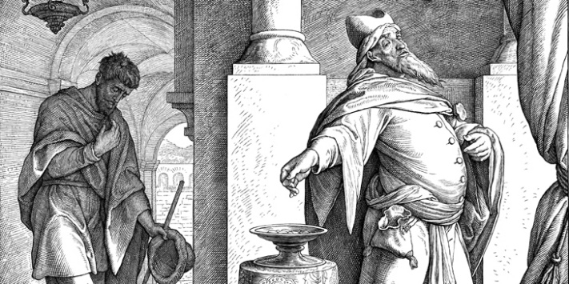

March 22nd Fourth Sunday in Lent
John 9:1-41
As Jesus walked along, he saw a man blind from birth. His disciples asked him, “Rabbi, who sinned, this man or his parents, that he was born blind?” Jesus answered, “Neither this man nor his parents sinned; he was born blind so that God’s works might be revealed in him. We must work the works of him who sent me while it is day; night is coming when no one can work. As long as I am in the world, I am the light of the world.” When he had said this, he spat on the ground and made mud with the saliva and spread the mud on the man’s eyes, saying to him, “Go, wash in the pool of Siloam” (which means Sent). Then he went and washed and came back able to see. The neighbors and those who had seen him before as a beggar began to ask, “Is this not the man who used to sit and beg?” Some were saying, “It is he.” Others were saying, “No, but it is someone like him.” He kept saying, “I am the man.” But they kept asking him, “Then how were your eyes opened?” He answered, “The man called Jesus made mud, spread it on my eyes, and said to me, ‘Go to Siloam and wash.’ Then I went and washed and received my sight.” They said to him, “Where is he?” He said, “I do not know.”
They brought to the Pharisees the man who had formerly been blind. Now it was a sabbath day when Jesus made the mud and opened his eyes. Then the Pharisees also began to ask him how he had received his sight. He said to them, “He put mud on my eyes. Then I washed, and now I see.” Some of the Pharisees said, “This man is not from God, for he does not observe the sabbath.” But others said, “How can a man who is a sinner perform such signs?” And they were divided. So they said again to the blind man, “What do you say about him? It was your eyes he opened.” He said, “He is a prophet.”
The Jews did not believe that he had been blind and had received his sight until they called the parents of the man who had received his sight and asked them, “Is this your son, who you say was born blind? How then does he now see?” His parents answered, “We know that this is our son, and that he was born blind; but we do not know how it is that now he sees, nor do we know who opened his eyes. Ask him; he is of age. He will speak for himself.” His parents said this because they were afraid of the Jews; for the Jews had already agreed that anyone who confessed Jesus to be the Messiah would be put out of the synagogue. Therefore his parents said, “He is of age; ask him.”
So for the second time they called the man who had been blind, and they said to him, “Give glory to God! We know that this man is a sinner.” He answered, “I do not know whether he is a sinner. One thing I do know, that though I was blind, now I see.” They said to him, “What did he do to you? How did he open your eyes?” He answered them, “I have told you already, and you would not listen. Why do you want to hear it again? Do you also want to become his disciples?” Then they reviled him, saying, “You are his disciple, but we are disciples of Moses. We know that God has spoken to Moses, but as for this man, we do not know where he comes from.” The man answered, “Here is an astonishing thing! You do not know where he comes from, and yet he opened my eyes. We know that God does not listen to sinners, but he does listen to one who worships him and obeys his will. Never since the world began has it been heard that anyone opened the eyes of a person born blind. If this man were not from God, he could do nothing.” They answered him, “You were born entirely in sins, and are you trying to teach us?” And they drove him out.
Jesus heard that they had driven him out, and when he found him, he said, “Do you believe in the Son of Man?” He answered, “And who is he, sir? Tell me, so that I may believe in him.” Jesus said to him, “You have seen him, and the one speaking with you is he.” He said, “Lord, I believe.” And he worshiped him. Jesus said, “I came into this world for judgment so that those who do not see may see, and those who do see may become blind.” Some of the Pharisees near him heard this and said to him, “Surely we are not blind, are we?” Jesus said to them, “If you were blind, you would not have sin. But now that you say, ‘We see,’ your sin remains.”

Amazing Grace
by John Newton

Amazing Grace, How sweet the sound
That saved a wretch like me
I once was lost, but now am found
T'was blind but now I see

T'was Grace that taught my heart to fear
And Grace, my fears relieved
How precious did that grace appear
The hour I first believed

Through many dangers, toils and snares
We have already come.
T'was grace that brought us safe thus far
And grace will lead us home,
And grace will lead us home

Amazing Grace, Howe Sweet the sound
That saved a wretch like me
I once was lost but now am found
T'was blind but now I see

March 23rd Monday in the Fourth Week of Lent

John 4:43–54
When the two days were over, Jesus went from that place to Galilee (for Jesus himself had testified that a prophet has no honor in the prophet’s own country). When he came to Galilee, the Galileans welcomed him, since they had seen all that he had done in Jerusalem at the festival; for they too had gone to the festival.
Then he came again to Cana in Galilee where he had changed the water into wine. Now there was a royal official whose son lay ill in Capernaum. When he heard that Jesus had come from Judea to Galilee, he went and begged him to come down and heal his son, for he was at the point of death. Then Jesus said to him, “Unless you see signs and wonders you will not believe.” The official said to him, “Sir, come down before my little boy dies.” Jesus said to him, “Go; your son will live.” The man believed the word that Jesus spoke to him and started on his way. As he was going down, his slaves met him and told him that his child was alive. So he asked them the hour when he began to recover, and they said to him, “Yesterday at one in the afternoon the fever left him.” The father realized that this was the hour when Jesus had said to him, “Your son will live.” So he himself believed, along with his whole household. Now this was the second sign that Jesus did after coming from Judea to Galilee.

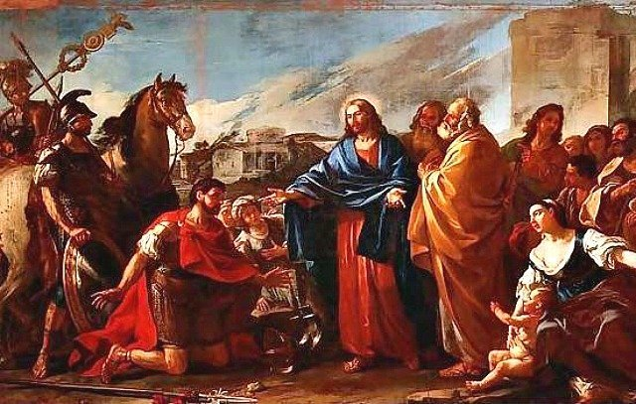

March 24th - Tuesday in the Fourth Week of Lent
John 5:1–18
There was a festival of the Jews, and Jesus went up to Jerusalem.
Now in Jerusalem by the Sheep Gate there is a pool, called in Hebrew Beth-zatha, which has five porticoes. In these lay many invalids—blind, lame, and paralyzed. One man was there who had been ill for thirty-eight years. When Jesus saw him lying there and knew that he had been there a long time, he said to him, “Do you want to be made well?” The sick man answered him, “Sir, I have no one to put me into the pool when the water is stirred up; and while I am making my way, someone else steps down ahead of me.” Jesus said to him, “Stand up, take your mat and walk.” At once the man was made well, and he took up his mat and began to walk.
Now that day was a sabbath. So the Jews said to the man who had been cured, “It is the sabbath; it is not lawful for you to carry your mat.” But he answered them, “The man who made me well said to me, ‘Take up your mat and walk.’” They asked him, “Who is the man who said to you, ‘Take it up and walk’?” Now the man who had been healed did not know who it was, for Jesus had disappeared in the crowd that was there. Later Jesus found him in the temple and said to him, “See, you have been made well! Do not sin any more, so that nothing worse happens to you.” The man went away and told the Jews that it was Jesus who had made him well. Therefore the Jews started persecuting Jesus, because he was doing such things on the sabbath. But Jesus answered them, “My Father is still working, and I also am working.” For this reason the Jews were seeking all the more to kill him, because he was not only breaking the sabbath, but was also calling God his own Father, thereby making himself equal to God.

At The Pool Of Bethesda –

by Royston Allen

I've been lying here for another year

feeling left all alone in my great fear.

So perhaps this time? You can never tell

Maybe it is my turn to be made well.

What's all the commotion that I can hear?

and why is this man coming over here?

It looks like He's heading towards my way.

and what is this that I've just heard him say?

'Do you want healing? ', To me He just said

Then 'Arise, walk now and take up your bed.'

Is this true and can it really be

that this great man is going to heal me?

Then entering this poor body of mine

came such wondrous healing from the Divine.

No angel was required, no water stirred

just from this man came the commanding word.

Then limbs for years that were lifeless and dead

became alive at the words that He said.

Then I could stand up to my great delight

and others witnessed the amazing sight.

The leaders said that this should never be.

For it was on the Sabbath He'd healed me

and I did not know the wonderful name

of this great Man who to Bethesda came.

So then I went to the temple to pray

and met Him again I am glad to say.

Then I found out His name and He told me

to stop sinning or much worse things would be.

So back to the leaders I went to tell

that it was Jesus who had made me well.

Why He had healed me, I can't really say

but I'm so glad that he healed me that day.

March 25th - Wednesday in the Fourth Week of Lent
Luke 1:26-38
In the sixth month the angel Gabriel was sent by God to a town in Galilee called Nazareth, to a virgin engaged to a man whose name was Joseph, of the house of David. The virgin's name was Mary. And he came to her and said, "Greetings, favored one! The Lord is with you." But she was much perplexed by his words and pondered what sort of greeting this might be. The angel said to her, "Do not be afraid, Mary, for you have found favor with God. And now, you will conceive in your womb and bear a son, and you will name him Jesus. He will be great, and will be called the Son of the Most High, and the Lord God will give to him the throne of his ancestor David. He will reign over the house of Jacob forever, and of his kingdom there will be no end." Mary said to the angel, "How can this be, since I am a virgin?" The angel said to her, "The Holy Spirit will come upon you, and the power of the Most High will overshadow you; therefore the child to be born will be holy; he will be called Son of God. And now, your relative Elizabeth in her old age has also conceived a son; and this is the sixth month for her who was said to be barren. For nothing will be impossible with God." Then Mary said, "Here am I, the servant of the Lord; let it be with me according to your word." Then the angel departed from her.

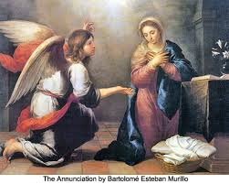

Apostle’s Prayer

Lord, when You called Abraham,

he responded, “Ready.”

When You called Isaiah, he answered,

“Here I am Lord.”

When the angel Gabriel called out to Mary,

she responded, “I am the handmaid of the Lord.

Let it be done to me according to your word.”

Lord, I hear You calling my name.

I hear You entrusting me with the task of building

Your kingdom. Like those holy men and women

who have gone before me,

I give You my ‘yes’!

I will go anywhere You want me to go.

I will do anything You want me to do.

I will say anything You want me to say.

Holy Spirit I welcome You and ask You to guide me.

Form in me an apostle’s heart

filled with love for Christ and zeal for souls.

I will commit myself with courage and generosity

to the New Evangelization. I will build, brick-by-brick,

the city of God inside the city of man.

Amen.

(Written by André and Angèle Regnier)

March 26th - Thursday in the Fourth Week of Lent
John 5:30–47
Jesus said, “I can do nothing on my own. As I hear, I judge; and my judgment is just, because I seek to do not my own will but the will of him who sent me.
“If I testify about myself, my testimony is not true. There is another who testifies on my behalf, and I know that his testimony to me is true. You sent messengers to John, and he testified to the truth. Not that I accept such human testimony, but I say these things so that you may be saved. He was a burning and shining lamp, and you were willing to rejoice for a while in his light. But I have a testimony greater than John’s. The works that the Father has given me to complete, the very works that I am doing, testify on my behalf that the Father has sent me. And the Father who sent me has himself testified on my behalf. You have never heard his voice or seen his form, and you do not have his word abiding in you, because you do not believe him whom he has sent.
“You search the scriptures because you think that in them you have eternal life; and it is they that testify on my behalf. Yet you refuse to come to me to have life. I do not accept glory from human beings. But I know that you do not have the love of God in you. I have come in my Father’s name, and you do not accept me; if another comes in his own name, you will accept him. How can you believe when you accept glory from one another and do not seek the glory that comes from the one who alone is God? Do not think that I will accuse you before the Father; your accuser is Moses, on whom you have set your hope. If you believed Moses, you would believe me, for he wrote about me. But if you do not believe what he wrote, how will you believe what I say?”

Lord, forgive me for not believing that your truth permeates every single layer of my life. Fan my tiny smoldering little spark of faith into a burning and consuming fire that will bring you glory and drive out darkness. But don’t ever let me think it is strong enough or that I have any hope of stoking it and keeping it alive apart from you. I believe; help my unbelief!

March 27th - Friday in the Fourth Week of Lent
John 7:1–2,10,25–30
After this Jesus went about in Galilee. He did not wish to go about in Judea because the Jews were looking for an opportunity to kill him. Now the Jewish festival of Booths was near.
But after his brothers had gone to the festival, then he also went, not publicly but as it were in secret.
Now some of the people of Jerusalem were saying, “Is not this the man whom they are trying to kill? And here he is, speaking openly, but they say nothing to him! Can it be that the authorities really know that this is the Messiah? Yet we know where this man is from; but when the Messiah comes, no one will know where he is from.” Then Jesus cried out as he was teaching in the temple, “You know me, and you know where I am from. I have not come on my own. But the one who sent me is true, and you do not know him. I know him, because I am from him, and he sent me.” Then they tried to arrest him, but no one laid hands on him, because his hour had not yet come.

O Lord, help me to remain firm in my trust in You in times of adversity, and to learn and grow strong from my trials. Wrap me in the folds of your strength and each day, together we will sail on.

Amen

March 28th Saturday in the Fourth Week of Lent
John 7:37–52
On the last day of the festival, the great day, while Jesus was standing there, he cried out, “Let anyone who is thirsty come to me, and let the one who believes in me drink. As the scripture has said, ‘Out of the believer’s heart shall flow rivers of living water.’” Now he said this about the Spirit, which believers in him were to receive; for as yet there was no Spirit, because Jesus was not yet glorified.
When they heard these words, some in the crowd said, “This is really the prophet.” Others said, “This is the Messiah.” But some asked, “Surely the Messiah does not come from Galilee, does he? Has not the scripture said that the Messiah is descended from David and comes from Bethlehem, the village where David lived?” So there was a division in the crowd because of him. Some of them wanted to arrest him, but no one laid hands on him.
Then the temple police went back to the chief priests and Pharisees, who asked them, “Why did you not arrest him?” The police answered, “Never has anyone spoken like this!” Then the Pharisees replied, “Surely you have not been deceived too, have you? Has any one of the authorities or of the Pharisees believed in him? But this crowd, which does not know the law—they are accursed.” Nicodemus, who had gone to Jesus before, and who was one of them, asked, “Our law does not judge people without first giving them a hearing to find out what they are doing, does it?” They replied, “Surely you are not also from Galilee, are you? Search and you will see that no prophet is to arise from Galilee.”

Life Giving Water

By Dave Hopwood

Extract from the poem:

Life leaves us thirsty, longing for more.
And in the parched streets
and arid busyness a single voice cries out,
'Let anyone who is thirsty come to me,
whether rich or poor,
happy or sad,
satisfied or frustrated,
privileged or marginalised.
Young or old, wanted or unwanted,
sick or healthy,
full of faith or wrestling with doubt.'

Life leaves us thirsty, longing for more.
And in the parched streets
and arid busyness a single voice cries out,
'The water I give, will become a life-giving spring,
welling up to eternal life.
Offering purpose, meaning, hope and direction.
So come to me and drink, and from your being will flow rivers of living water,
streaming out to those around.'...

March 29th - Fifth Sunday in Lent

John 11:1-45
Now a certain man was ill, Lazarus of Bethany, the village of Mary and her sister Martha. Mary was the one who anointed the Lord with perfume and wiped his feet with her hair; her brother Lazarus was ill. So the sisters sent a message to Jesus, “Lord, he whom you love is ill.” But when Jesus heard it, he said, “This illness does not lead to death; rather it is for God’s glory, so that the Son of God may be glorified through it.” Accordingly, though Jesus loved Martha and her sister and Lazarus, after having heard that Lazarus was ill, he stayed two days longer in the place where he was.
Then after this he said to the disciples, “Let us go to Judea again.” The disciples said to him, “Rabbi, the Jews were just now trying to stone you, and are you going there again?” Jesus answered, “Are there not twelve hours of daylight? Those who walk during the day do not stumble, because they see the light of this world. But those who walk at night stumble, because the light is not in them.” After saying this, he told them, “Our friend Lazarus has fallen asleep, but I am going there to awaken him.” The disciples said to him, “Lord, if he has fallen asleep, he will be all right.” Jesus, however, had been speaking about his death, but they thought that he was referring merely to sleep. Then Jesus told them plainly, “Lazarus is dead. For your sake I am glad I was not there, so that you may believe. But let us go to him.” Thomas, who was called the Twin, said to his fellow disciples, “Let us also go, that we may die with him.”
When Jesus arrived, he found that Lazarus had already been in the tomb four days. Now Bethany was near Jerusalem, some two miles away, and many of the Jews had come to Martha and Mary to console them about their brother. When Martha heard that Jesus was coming, she went and met him, while Mary stayed at home. Martha said to Jesus, “Lord, if you had been here, my brother would not have died. But even now I know that God will give you whatever you ask of him.” Jesus said to her, “Your brother will rise again.” Martha said to him, “I know that he will rise again in the resurrection on the last day.” Jesus said to her, “I am the resurrection and the life. Those who believe in me, even though they die, will live, and everyone who lives and believes in me will never die. Do you believe this?” She said to him, “Yes, Lord, I believe that you are the Messiah, the Son of God, the one coming into the world.”
When she had said this, she went back and called her sister Mary, and told her privately, “The Teacher is here and is calling for you.” And when she heard it, she got up quickly and went to him. Now Jesus had not yet come to the village, but was still at the place where Martha had met him. The Jews who were with her in the house, consoling her, saw Mary get up quickly and go out. They followed her because they thought that she was going to the tomb to weep there. When Mary came where Jesus was and saw him, she knelt at his feet and said to him, “Lord, if you had been here, my brother would not have died.” When Jesus saw her weeping, and the Jews who came with her also weeping, he was greatly disturbed in spirit and deeply moved. He said, “Where have you laid him?” They said to him, “Lord, come and see.” Jesus began to weep. So the Jews said, “See how he loved him!” But some of them said, “Could not he who opened the eyes of the blind man have kept this man from dying?”
Then Jesus, again greatly disturbed, came to the tomb. It was a cave, and a stone was lying against it. Jesus said, “Take away the stone.” Martha, the sister of the dead man, said to him, “Lord, already there is a stench because he has been dead four days.” Jesus said to her, “Did I not tell you that if you believed, you would see the glory of God?” So they took away the stone. And Jesus looked upward and said, “Father, I thank you for having heard me. I knew that you always hear me, but I have said this for the sake of the crowd standing here, so that they may believe that you sent me.” When he had said this, he cried with a loud voice, “Lazarus, come out!” The dead man came out, his hands and feet bound with strips of cloth, and his face wrapped in a cloth. Jesus said to them, “Unbind him, and let him go.”
Many of the Jews therefore, who had come with Mary and had seen what Jesus did, believed in him.

This dramatic story, full of graphic details and ironic features, occurs only In the Gospel of John, where Jesus’ bestowal of life on the dead Lazarus serves as the catalyst of the conspiracy to put Jesus to death. In the other Gospels it is Jesus’ threat to destroy the temple that crystalizes opposition to him. But in John’s Gospel, with a characteristic irony, it is Jesus’ capacity to give life that causes others to seek his death.

The interplay of life and death, light and darkness, truth and falsehood, belief and unbelief, is repeatedly featured in John’s Gospel. Here it comes to a climax. Already in the prologue (1:4) the claim is made, “in him was life, and the life was the light of all people.” The raising of Lazarus is a narrative exemplification of this claim, a “revelation” of Jesus’ life-giving power.

Here Jesus proclaims, “I am the resurrection and the life. Those who believe in me, even though they die, will live, and whoever lives and believes in me will never die.” When Jesus speaks of believers living and never dying, he must have had in mind something more and different than merely physical life and death. And, indeed, in John’s Gospel “life” is generally understood as a quality of life, as life lived in alert responsiveness to the divine presence mediated by Jesus. That is the form of life that is not interrupted by death. Thus, even as Jesus’ words assure Mary of the believer’s life after death, they should also remind us that Jesus is the source of our life before death. Faith does not mortgage the present to the future. Rather, to have faith in Jesus is to share now in him who is life. Thus, the story of Lazarus might prompt us, during Lent, to examine our vital signs.

-Harry Gamble

March 30th - Monday in the Fifth Week of Lent
John 8:12–20
Jesus spoke to the people, saying, “I am the light of the world. Whoever follows me will never walk in darkness but will have the light of life.” Then the Pharisees said to him, “You are testifying on your own behalf; your testimony is not valid.” Jesus answered, “Even if I testify on my own behalf, my testimony is valid because I know where I have come from and where I am going, but you do not know where I come from or where I am going. You judge by human standards; I judge no one. Yet even if I do judge, my judgment is valid; for it is not I alone who judge, but I and the Father who sent me. In your law it is written that the testimony of two witnesses is valid. I testify on my own behalf, and the Father who sent me testifies on my behalf.” Then they said to him, “Where is your Father?” Jesus answered, “You know neither me nor my Father. If you knew me, you would know my Father also.” He spoke these words while he was teaching in the treasury of the temple, but no one arrested him, because his hour had not yet come.

Heavenly Father,

Even when temptation has a hold on me, give me the wisdom and strength to follow you.

When my path seems dark, please help me to follow the light.

Thank you for being there to guide me.

Thank you for never leaving me.

I will follow you,

Amen.

March 31st - Tuesday in the Fifth Week of Lent
John 8:21–30
Jesus said to the Jews, “I am going away, and you will search for me, but you will die in your sin. Where I am going, you cannot come.” Then the Jews said, “Is he going to kill himself? Is that what he means by saying, ‘Where I am going, you cannot come’?” He said to them, “You are from below, I am from above; you are of this world, I am not of this world. I told you that you would die in your sins, for you will die in your sins unless you believe that I am he.” They said to him, “Who are you?” Jesus said to them, “Why do I speak to you at all? I have much to say about you and much to condemn; but the one who sent me is true, and I declare to the world what I have heard from him.” They did not understand that he was speaking to them about the Father. So Jesus said, “When you have lifted up the Son of Man, then you will realize that I am he, and that I do nothing on my own, but I speak these things as the Father instructed me. And the one who sent me is with me; he has not left me alone, for I always do what is pleasing to him.” As he was saying these things, many believed in him.

Dear Lord, Creator of all mankind, make me a channel through which Thy divine love may reach the lives of some of those who are near to me. Give me a heart sensitive to the needs of those with whom I may differ.

Amen

April 1st - Wednesday in the Fifth Week of Lent
John 8:31–42
Jesus said to the Jews who had believed in him, “If you continue in my word, you are truly my disciples; and you will know the truth, and the truth will make you free.” They answered him, “We are descendants of Abraham and have never been slaves to anyone. What do you mean by saying, ‘You will be made free’?”
Jesus answered them, “Very truly, I tell you, everyone who commits sin is a slave to sin. The slave does not have a permanent place in the household; the son has a place there forever. So if the Son makes you free, you will be free indeed. I know that you are descendants of Abraham; yet you look for an opportunity to kill me, because there is no place in you for my word. I declare what I have seen in the Father’s presence; as for you, you should do what you have heard from the Father.”
They answered him, “Abraham is our father.” Jesus said to them, “If you were Abraham’s children, you would be doing what Abraham did, but now you are trying to kill me, a man who has told you the truth that I heard from God. This is not what Abraham did. You are indeed doing what your father does.” They said to him, “We are not illegitimate children; we have one father, God himself.” Jesus said to them, “If God were your Father, you would love me, for I came from God and now I am here. I did not come on my own, but he sent me.”

Free Indeed
Why do you hide
behind the lies
shielding your eyes
from the beautiful truth?

Why do you bend
beneath your shame
the weight of your pain
breaking your heart?

Do you not know
that it is the
truth
that sets you free?

Do you not know
that if the Son sets you
free
you will be
free indeed?

So please
don’t hide
don’t bend
stand straight
head high

And remember,
you are free
you are beloved
oh precious one.

From the Way of Delight Blog

April 2nd - Thursday in the Fifth Week of Lent
John 8:51–59
Jesus said, “Very truly, I tell you, whoever keeps my word will never see death.” The Jews said to him, “Now we know that you have a demon. Abraham died, and so did the prophets; yet you say, ‘Whoever keeps my word will never taste death.’ Are you greater than our father Abraham, who died? The prophets also died. Who do you claim to be?” Jesus answered, “If I glorify myself, my glory is nothing. It is my Father who glorifies me, he of whom you say, ‘He is our God,’ though you do not know him. But I know him; if I would say that I do not know him, I would be a liar like you. But I do know him and I keep his word. Your ancestor Abraham rejoiced that he would see my day; he saw it and was glad.” Then the Jews said to him, “You are not yet fifty years old, and have you seen Abraham?” Jesus said to them, “Very truly, I tell you, before Abraham was, I am.” So they picked up stones to throw at him, but Jesus hid himself and went out of the temple.

April 3rd - Friday in the Fifth Week of Lent
John 10:31–42
The Jews took up stones again to stone Jesus. Jesus replied, “I have shown you many good works from the Father. For which of these are you going to stone me?” The Jews answered, “It is not for a good work that we are going to stone you, but for blasphemy, because you, though only a human being, are making yourself God.” Jesus answered, “Is it not written in your law, ‘I said, you are gods’? If those to whom the word of God came were called ‘gods’ —and the scripture cannot be annulled— can you say that the one whom the Father has sanctified and sent into the world is blaspheming because I said, ‘I am God’s Son’? If I am not doing the works of my Father, then do not believe me. But if I do them, even though you do not believe me, believe the works, so that you may know and understand that the Father is in me and I am in the Father.” Then they tried to arrest him again, but he escaped from their hands.
He went away again across the Jordan to the place where John had been baptizing earlier, and he remained there. Many came to him, and they were saying, “John performed no sign, but everything that John said about this man was true.” And many believed in him there.

God,
You love me as your own child.
May I bend my life and will toward you
so that I might accept your teaching and guidance.
I am so grateful for your support in my life,
now and in the eternal life you are preparing for me.
I beg for your help and Spirit in my life today.
Amen

April 4th - Saturday in the Fifth Week of Lent
John 11:45–53
Many of the Jews who had come with Mary and had seen what Jesus did, believed in him. But some of them went to the Pharisees and told them what he had done. So the chief priests and the Pharisees called a meeting of the council, and said, “What are we to do? This man is performing many signs. If we let him go on like this, everyone will believe in him, and the Romans will come and destroy both our holy place and our nation.” But one of them, Caiaphas, who was high priest that year, said to them, “You know nothing at all! You do not understand that it is better for you to have one man die for the people than to have the whole nation destroyed.” He did not say this on his own, but being high priest that year he prophesied that Jesus was about to die for the nation, and not for the nation only, but to gather into one the dispersed children of God. So from that day on they planned to put him to death.

Fear is what crucified Jesus and from fear he delivers us if we have faith in his message….

Almighty God,
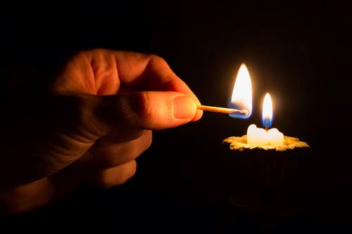
You reach into the darkness with hope, truth and light. Stretch out your strong hand in this situation, hold and rescue those who have suffered. Let your almighty love move mountains, cross seas and breathe life into the darkest places. Light that redeems. Light that restores. Light that heals. Light that protects. Light that saves. There is nothing higher, stronger or greater than your love. We trust in you.
Amen

April 5th - Palm Sunday

Matthew 27:11-54-
Jesus stood before the governor; and the governor asked him, “Are you the King of the Jews?” Jesus said, “You say so.” But when he was accused by the chief priests and elders, he did not answer. Then Pilate said to him, “Do you not hear how many accusations they make against you?” But he gave him no answer, not even to a single charge, so that the governor was greatly amazed.
Now at the festival the governor was accustomed to release a prisoner for the crowd, anyone whom they wanted. At that time they had a notorious prisoner, called Jesus Barabbas. So after they had gathered, Pilate said to them, “Whom do you want me to release for you, Jesus Barabbas or Jesus who is called the Messiah?” For he realized that it was out of jealousy that they had handed him over. While he was sitting on the judgment seat, his wife sent word to him, “Have nothing to do with that innocent man, for today I have suffered a great deal because of a dream about him.” Now the chief priests and the elders persuaded the crowds to ask for Barabbas and to have Jesus killed. The governor again said to them, “Which of the two do you want me to release for you?” And they said, “Barabbas.” Pilate said to them, “Then what should I do with Jesus who is called the Messiah?” All of them said, “Let him be crucified!” Then he asked, “Why, what evil has he done?” But they shouted all the more, “Let him be crucified!”
So when Pilate saw that he could do nothing, but rather that a riot was beginning, he took some water and washed his hands before the crowd, saying, “I am innocent of this man’s blood; see to it yourselves.” Then the people as a whole answered, “His blood be on us and on our children!” So he released Barabbas for them; and after flogging Jesus, he handed him over to be crucified.
Then the soldiers of the governor took Jesus into the governor’s headquarters, and they gathered the whole cohort around him. They stripped him and put a scarlet robe on him, and after twisting some thorns into a crown, they put it on his head. They put a reed in his right hand and knelt before him and mocked him, saying, “Hail, King of the Jews!” They spat on him, and took the reed and struck him on the head. After mocking him, they stripped him of the robe and put his own clothes on him. Then they led him away to crucify him.
As they went out, they came upon a man from Cyrene named Simon; they compelled this man to carry his cross. And when they came to a place called Golgotha (which means Place of a Skull), they offered him wine to drink, mixed with gall; but when he tasted it, he would not drink it. And when they had crucified him, they divided his clothes among themselves by casting lots; then they sat down there and kept watch over him. Over his head they put the charge against him, which read, “This is Jesus, the King of the Jews.”
Then two bandits were crucified with him, one on his right and one on his left. Those who passed by derided him, shaking their heads and saying, “You who would destroy the temple and build it in three days, save yourself! If you are the Son of God, come down from the cross.” In the same way the chief priests also, along with the scribes and elders, were mocking him, saying, “He saved others; he cannot save himself. He is the King of Israel; let him come down from the cross now, and we will believe in him. He trusts in God; let God deliver him now, if he wants to; for he said, ‘I am God’s Son.’” The bandits who were crucified with him also taunted him in the same way.
From noon on, darkness came over the whole land until three in the afternoon. And about three o’clock Jesus cried with a loud voice, “Eli, Eli, lema sabachthani?” that is, “My God, my God, why have you forsaken me?” When some of the bystanders heard it, they said, “This man is calling for Elijah.” At once one of them ran and got a sponge, filled it with sour wine, put it on a stick, and gave it to him to drink. But the others said, “Wait, let us see whether Elijah will come to save him.” Then Jesus cried again with a loud voice and breathed his last. At that moment the curtain of the temple was torn in two, from top to bottom. The earth shook, and the rocks were split. The tombs also were opened, and many bodies of the saints who had fallen asleep were raised. After his resurrection they came out of the tombs and entered the holy city and appeared to many. Now when the centurion and those with him, who were keeping watch over Jesus, saw the earthquake and what took place, they were terrified and said, “Truly this man was God’s Son!”

Blessing of Palms
This blessing
can be heard coming
from a long way off.
This blessing
is making

its steady way
up the road
toward you.
This blessing
blooms in the throats
of women,
springs from the hearts
of men,
tumbles out of the mouths
of children.
This blessing
is stitched into
the seams
of the cloaks
that line the road,
etched into
the branches
that trace the path,
echoes in
the breathing
of the willing colt,
the click
of the donkey’s hoof
against the stones.
Something is rising
beneath this blessing.
Something will try
to drown it out.
But this blessing
cannot be turned back,
cannot be made
to still its voice,
cannot cease
to sing its praise
of the One who comes
along the way
it makes.

—Jan Richardson
from Circle of Grace: A Book of Blessings for the Seasons
April 6th - Monday in Holy Week

John 12:1-11
Six days before the Passover Jesus came to Bethany, the home of Lazarus, whom he had raised from the dead. There they gave a dinner for him. Martha served, and Lazarus was one of those at the table with him. Mary took a pound of costly perfume made of pure nard, anointed Jesus' feet, and wiped them with her hair. The house was filled with the fragrance of the perfume. But Judas Iscariot, one of his disciples (the one who was about to betray him), said, "Why was this perfume not sold for three hundred denarii and the money given to the poor?" (He said this not because he cared about the poor, but because he was a thief; he kept the common purse and used to steal what was put into it.) Jesus said, "Leave her alone. She bought it so that she might keep it for the day of my burial. You always have the poor with you, but you do not always have me." When the great crowd of the Jews learned that he was there, they came not only because of Jesus but also to see Lazarus, whom he had raised from the dead. So the chief priests planned to put Lazarus to death as well, since it was on account of him that many of the Jews were deserting and were believing in Jesus.
Blessing of Balm
When we see
the body of Christ
still broken in this world,
may we meet it
with lavish grace
and pour ourselves out
with extravagant love.
—Jan Richardson

April 7th Tuesday in Holy Week

John 12:20-36
Among those who went up to worship at the festival were some Greeks. They came to Philip, who was from Bethsaida in Galilee, and said to him, "Sir, we wish to see Jesus." Philip went and told Andrew; then Andrew and Philip went and told Jesus. Jesus answered them, "The hour has come for the Son of Man to be glorified. Very truly, I tell you, unless a grain of wheat falls into the earth and dies, it remains just a single grain; but if it dies, it bears much fruit. Those who love their life lose it, and those who hate their life in this world will keep it for eternal life. Whoever serves me must follow me, and where I am, there will my servant be also. Whoever serves me, the Father will honor.
"Now my soul is troubled. And what should I say-- `Father, save me from this hour'? No, it is for this reason that I have come to this hour. Father, glorify your name." Then a voice came from heaven, "I have glorified it, and I will glorify it again." The crowd standing there heard it and said that it was thunder. Others said, "An angel has spoken to him." Jesus answered, "This voice has come for your sake, not for mine. Now is the judgment of this world; now the ruler of this world will be driven out. And I, when I am lifted up from the earth, will draw all people to myself." He said this to indicate the kind of death he was to die. The crowd answered him, "We have heard from the law that the Messiah remains forever. How can you say that the Son of Man must be lifted up? Who is this Son of Man?" Jesus said to them, "The light is with you for a little longer. Walk while you have the light, so that the darkness may not overtake you. If you walk in the darkness, you do not know where you are going. While you have the light, believe in the light, so that you may become children of light."
After Jesus had said this, he departed and hid from them.

If Jesus is The Light
And you believe in Him
You then are a ’Child of the Light’
So close your eyes
Sense the thin thread of divine Light
Connect with it
As He said
“Walk in the light”
So
Envision it
Move into it
Reach for it
Envelope it
Blanket yourself in it
Absorb it
Breathe it in
Consider it faith
Then live it
Speak it
Embrace it, share it
Walk it, talk it, spread it
Every single hour
Of every single day
All of the time
And into forever
And all will be divine.

-Judith Truesdail

April 8^{th-} Wednesday in Holy Week

John 13:21-32
At supper with his friends, Jesus was troubled in spirit, and declared, "Very truly, I tell you, one of you will betray me." The disciples looked at one another, uncertain of whom he was speaking. One of his disciples-- the one whom Jesus loved-- was reclining next to him; Simon Peter therefore motioned to him to ask Jesus of whom he was speaking. So while reclining next to Jesus, he asked him, "Lord, who is it?" Jesus answered, "It is the one to whom I give this piece of bread when I have dipped it in the dish." So when he had dipped the piece of bread, he gave it to Judas son of Simon Iscariot. After he received the piece of bread, Satan entered into him. Jesus said to him, "Do quickly what you are going to do." Now no one at the table knew why he said this to him. Some thought that, because Judas had the common purse, Jesus was telling him, "Buy what we need for the festival"; or, that he should give something to the poor. So, after receiving the piece of bread, he immediately went out. And it was night.
When he had gone out, Jesus said, "Now the Son of Man has been glorified, and God has been glorified in him. If God has been glorified in him, God will also glorify him in himself and will glorify him at once."
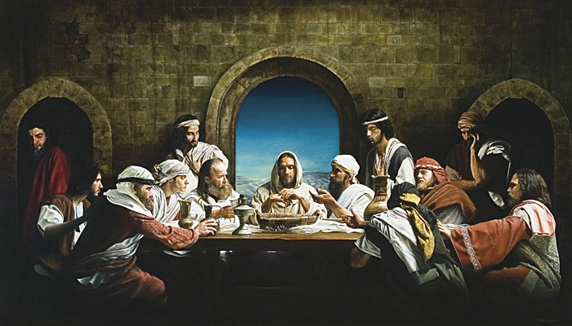 And it was Night by Ben McPherson
Lord God,
We tremble to think
That it was one of Jesus’ own friends who betrayed him.
One who sat by him, who broke bread with him.
Give us strength, we pray,
To walk faithfully with Jesus,
Even when the road we walk is rocky
Even when the message of the cross seems like foolishness
And even when we feel betrayed.
You, Lord, are always faithful.
We stumble, we become lost,
But you are steady and sure.
Give us the grace to endure our troubles,
And reveal to us the glory of your kingdom,
Through your son, Jesus Christ, who lives and reigns with you and the Holy Spirit.
Amen.

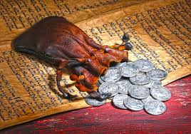

April 9th - Maundy Thursday

John 13:1-17, 31b-35
Now before the festival of the Passover, Jesus knew that his hour had come to depart from this world and go to the Father. Having loved his own who were in the world, he loved them to the end. The devil had already put it into the heart of Judas son of Simon Iscariot to betray him. And during supper Jesus, knowing that the Father had given all things into his hands, and that he had come from God and was going to God, got up from the table, took off his outer robe, and tied a towel around himself. Then he poured water into a basin and began to wash the disciples' feet and to wipe them with the towel that was tied around him. He came to Simon Peter, who said to him, "Lord, are you going to wash my feet?" Jesus answered, "You do not know now what I am doing, but later you will understand." Peter said to him, "You will never wash my feet." Jesus answered, "Unless I wash you, you have no share with me." Simon Peter said to him, "Lord, not my feet only but also my hands and my head!" Jesus said to him, "One who has bathed does not need to wash, except for the feet, but is entirely clean. And you are clean, though not all of you." For he knew who was to betray him; for this reason he said, "Not all of you are clean."
After he had washed their feet, had put on his robe, and had returned to the table, he said to them, "Do you know what I have done to you? You call me Teacher and Lord--and you are right, for that is what I am. So if I, your Lord and Teacher, have washed your feet, you also ought to wash one another's feet. For I have set you an example, that you also should do as I have done to you. Very truly, I tell you, servants are not greater than their master, nor are messengers greater than the one who sent them. If you know these things, you are blessed if you do them.
"Now the Son of Man has been glorified, and God has been glorified in him. If God has been glorified in him, God will also glorify him in himself and will glorify him at once. Little children, I am with you only a little longer. You will look for me; and as I said to the Jews so now I say to you, `Where I am going, you cannot come.' I give you a new commandment, that you love one another. Just as I have loved you, you also should love one another. By this everyone will know that you are my disciples, if you have love for one another."

Blessing You Cannot Turn Back
As if you could
stop this blessing
from washing
over you.
As if you could
turn it back,
could return it
from your body
to the bowl,
from the bowl
to the pitcher,
from the pitcher
to the hand
that set this blessing
on its way.
As if you could
change the course
by which this blessing
flows.
As if you could
control how it
pours over you—
unbidden,
unsought,
unasked,
yet startling
in the way
it matches the need
you did not know
you had.
As if you could
become undrenched.
As if you could
resist gathering it up
in your two hands
and letting your body
follow the arc
this blessing makes.
—Jan Richardson
from Circle of Grace

April 10th - Good Friday
John 18:1-19:42
Jesus went out with his disciples across the Kidron valley to a place where there was a garden, which he and his disciples entered. Now Judas, who betrayed him, also knew the place, because Jesus often met there with his disciples. So Judas brought a detachment of soldiers together with police from the chief priests and the Pharisees, and they came there with lanterns and torches and weapons. Then Jesus, knowing all that was to happen to him, came forward and asked them, "Whom are you looking for?" They answered, "Jesus of Nazareth." Jesus replied, "I am he." Judas, who betrayed him, was standing with them. When Jesus said to them, "I am he," they stepped back and fell to the ground. Again he asked them, "Whom are you looking for?" And they said, "Jesus of Nazareth." Jesus answered, "I told you that I am he. So if you are looking for me, let these men go." This was to fulfill the word that he had spoken, "I did not lose a single one of those whom you gave me." Then Simon Peter, who had a sword, drew it, struck the high priest's slave, and cut off his right ear. The slave's name was Malchus. Jesus said to Peter, "Put your sword back into its sheath. Am I not to drink the cup that the Father has given me?"
So the soldiers, their officer, and the Jewish police arrested Jesus and bound him. First they took him to Annas, who was the father-in-law of Caiaphas, the high priest that year. Caiaphas was the one who had advised the Jews that it was better to have one person die for the people.
Simon Peter and another disciple followed Jesus. Since that disciple was known to the high priest, he went with Jesus into the courtyard of the high priest, but Peter was standing outside at the gate. So the other disciple, who was known to the high priest, went out, spoke to the woman who guarded the gate, and brought Peter in. The woman said to Peter, "You are not also one of this man's disciples, are you?" He said, "I am not." Now the slaves and the police had made a charcoal fire because it was cold, and they were standing around it and warming themselves. Peter also was standing with them and warming himself.
Then the high priest questioned Jesus about his disciples and about his teaching. Jesus answered, "I have spoken openly to the world; I have always taught in synagogues and in the temple, where all the Jews come together. I have said nothing in secret. Why do you ask me? Ask those who heard what I said to them; they know what I said." When he had said this, one of the police standing nearby struck Jesus on the face, saying, "Is that how you answer the high priest?" Jesus answered, "If I have spoken wrongly, testify to the wrong. But if I have spoken rightly, why do you strike me?" Then Annas sent him bound to Caiaphas the high priest.
Now Simon Peter was standing and warming himself. They asked him, "You are not also one of his disciples, are you?" He denied it and said, "I am not." One of the slaves of the high priest, a relative of the man whose ear Peter had cut off, asked, "Did I not see you in the garden with him?" Again Peter denied it, and at that moment the cock crowed.
Then they took Jesus from Caiaphas to Pilate's headquarters. It was early in the morning. They themselves did not enter the headquarters, so as to avoid ritual defilement and to be able to eat the Passover. So Pilate went out to them and said, "What accusation do you bring against this man?" They answered, "If this man were not a criminal, we would not have handed him over to you." Pilate said to them, "Take him yourselves and judge him according to your law." The Jews replied, "We are not permitted to put anyone to death." (This was to fulfill what Jesus had said when he indicated the kind of death he was to die.)
Then Pilate entered the headquarters again, summoned Jesus, and asked him, "Are you the King of the Jews?" Jesus answered, "Do you ask this on your own, or did others tell you about me?" Pilate replied, "I am not a Jew, am I? Your own nation and the chief priests have handed you over to me. What have you done?" Jesus answered, "My kingdom is not from this world. If my kingdom were from this world, my followers would be fighting to keep me from being handed over to the Jews. But as it is, my kingdom is not from here." Pilate asked him, "So you are a king?" Jesus answered, "You say that I am a king. For this I was born, and for this I came into the world, to testify to the truth. Everyone who belongs to the truth listens to my voice." Pilate asked him, "What is truth?"
After he had said this, he went out to the Jews again and told them, "I find no case against him. But you have a custom that I release someone for you at the Passover. Do you want me to release for you the King of the Jews?" They shouted in reply, "Not this man, but Barabbas!" Now Barabbas was a bandit.
Then Pilate took Jesus and had him flogged. And the soldiers wove a crown of thorns and put it on his head, and they dressed him in a purple robe. They kept coming up to him, saying, "Hail, King of the Jews!" and striking him on the face. Pilate went out again and said to them, "Look, I am bringing him out to you to let you know that I find no case against him." So Jesus came out, wearing the crown of thorns and the purple robe. Pilate said to them, "Here is the man!" When the chief priests and the police saw him, they shouted, "Crucify him! Crucify him!" Pilate said to them, "Take him yourselves and crucify him; I find no case against him." The Jews answered him, "We have a law, and according to that law he ought to die because he has claimed to be the Son of God."
Now when Pilate heard this, he was more afraid than ever. He entered his headquarters again and asked Jesus, "Where are you from?" But Jesus gave him no answer. Pilate therefore said to him, "Do you refuse to speak to me? Do you not know that I have power to release you, and power to crucify you?" Jesus answered him, "You would have no power over me unless it had been given you from above; therefore the one who handed me over to you is guilty of a greater sin." From then on Pilate tried to release him, but the Jews cried out, "If you release this man, you are no friend of the emperor. Everyone who claims to be a king sets himself against the emperor."
When Pilate heard these words, he brought Jesus outside and sat on the judge's bench at a place called The Stone Pavement, or in Hebrew Gabbatha. Now it was the day of Preparation for the Passover; and it was about noon. He said to the Jews, "Here is your King!" They cried out, "Away with him! Away with him! Crucify him!" Pilate asked them, "Shall I crucify your King?" The chief priests answered, "We have no king but the emperor." Then he handed him over to them to be crucified.
So they took Jesus; and carrying the cross by himself, he went out to what is called The Place of the Skull, which in Hebrew is called Golgotha. There they crucified him, and with him two others, one on either side, with Jesus between them. Pilate also had an inscription written and put on the cross. It read, "Jesus of Nazareth, the King of the Jews." Many of the Jews read this inscription, because the place where Jesus was crucified was near the city; and it was written in Hebrew, in Latin, and in Greek. Then the chief priests of the Jews said to Pilate, "Do not write, 'The King of the Jews,' but, 'This man said, I am King of the Jews.'" Pilate answered, "What I have written I have written." When the soldiers had crucified Jesus, they took his clothes and divided them into four parts, one for each soldier. They also took his tunic; now the tunic was seamless, woven in one piece from the top. So they said to one another, "Let us not tear it, but cast lots for it to see who will get it." This was to fulfill what the scripture says,
"They divided my clothes among themselves,
and for my clothing they cast lots."
And that is what the soldiers did.

Jesus, no one knows change better than you. You died on the cross, and three days later you rose from the dead. Forty days later you ascended into heaven and left the world transformed for the rest of time. Help me to transform my soul, to die to sin and death and be reborn in your love and eternal life. Amen.
April 11th - Holy Saturday Easter Vigil
Matthew 27:57-66
When it was evening, there came a rich man from Arimathea, named Joseph, who was also a disciple of Jesus. He went to Pilate and asked for the body of Jesus; then Pilate ordered it to be given to him. So Joseph took the body and wrapped it in a clean linen cloth and laid it in his own new tomb, which he had hewn in the rock. He then rolled a great stone to the door of the tomb and went away. Mary Magdalene and the other Mary were there, sitting opposite the tomb.
The next day, that is, after the day of Preparation, the chief priests and the Pharisees gathered before Pilate and said, "Sir, we remember what that impostor said while he was still alive, `After three days I will rise again.' Therefore command the tomb to be made secure until the third day; otherwise his disciples may go and steal him away, and tell the people, `He has been raised from the dead,' and the last deception would be worse than the first." Pilate said to them, "You have a guard of soldiers; go, make it as secure as you can." So they went with the guard and made the tomb secure by sealing the stone.

Loving Creator of mine,
I feel the pace quicken, the time draw near.
I am filled with joy as I move toward Easter
and the promised reconciliation with you.
Teach me to follow the example of your Son,
to be worthy of being called one his people:
a Christ-ian.
Help me to live each day as he did
turning hatred to love and conflict to peace.
I await the new life with eagerness, faith
and a deep gratitude.
Amen

Sunday, April 12th- Easter Day

EASTER BLESSING

"On this Easter morning, let us look again at the lives we have been so generously given and let us let fall away the useless baggage that we carry -- old pains, old habits, old ways of seeing and feeling -- and let us have the courage to begin again. Life is very short, and we are no sooner here than it is time to depart again, and we should use to the full the time that we still have.
We don't realize all the good we can do. A kind, encouraging word or helping hand can bring many a person through dark valleys in their lives. We weren't put here to make money or to acquire status or reputation. We were sent here to search for the light of Easter in our hearts, and when we find it we are meant to give it away generously. The dawn that is rising this Easter morning is a gift to our hearts and we are meant to celebrate it and to carry away from this holy, ancient place the gifts of healing and light and the courage of a new beginning."

John O'Donohue
Dawn Mass Reflections at Corcomroe Abbey

